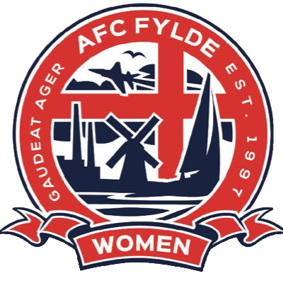
JOB DESCRIPTION

JOB TITLE: First Team Head Coach

REPORTS TO: Director of Football
Chief Operating Officer

KEY RELATIONSHIPS: AFC Fylde Commercial & Media
Mill Farm Director of Leisure
AFC Fylde Boys Academy
Grounds Team

HOURS: Full time role to include two nights of evening training sessions and Sunday matchday. Remaining hours will be office based at AFC Fylde Mill Farm

DATE: December 2024

ROLE SUMMARY

The successful candidate will not only be the First Team Head Coach but also the person responsible for helping to drive the growth of the club’s female football programme. This is a new and exciting full time role to deliver on all female football projects. This includes full responsibility for AFC Fylde Women’s First Team as well as the development and delivery of a new junior pathway.
BACKGROUND
Role Summary

AFC Fylde are operating in a highly competitive market. On the Fylde Coast there are currently two other professional football clubs, Blackpool FC and Fleetwood Town, and also one semi-professional rugby team, Fylde RUFC, who are all competing for the same audience. Our facilities are second to none and we want to continue to grow across all areas of the football club, setting best practise operational standards. Our women’s team has a history of success and are amongst the top three ranked teams in Lancashire. We are one of a handful of teams in the country to have a standalone ground, together with state of the art training facilities, including our own all-weather pitches. Our plan is to achieve Championship status within five years and this role will be pivotal in taking this project forward.

SPECIFIC RESPONSIBILITIES
Role Summary

Elite Performance and Culture
- Foster an elite culture both on and off the pitch.
- Develop, build and lead a team of coaching staff to improve the first team performance and growth.
- Responsible for ensuring best in class player recruitment and retention.

Coaching and Development
- Plan and deliver high quality training plans aligned with coaching team and club’s playing philosophy.
- Oversee and implement players individual personal development plans.
- Design a performance calendar across the club from pre-season to off-season.
- Support the development and future implementation of an U18’s feeder ream with the potential for future age groups.

Football Operations and Strategy
- Initially responsible for organising and control all aspects of the AFC Fylde Women’s structure including match arrangement and organisation, kit control, matchday organisation.
- Help oversee the upkeep and development of our Women’s ground at Kellemergh Park.
- Recruit and lead a team of volunteers to help manage Kellemergh Park activities on Matchdays.
- Ensure projects are aligned with agreed plans and all club administration is kept up to date and in a timely manner.

Public Relations and Representation
- Work closely with AFC Fylde media departments to ensure the women’s team are always at the forefront of everyone’s minds.
- Represent AFC Fylde Women in media engagements, public events, and club appearances.
- Form close links with the club Community Foundation
- Work with key partners to understand the current women’s football landscape in the Borough of Fylde to help identify how AFC Fylde can lead in this arena.
- Ensure all activities are correctly monitored with the appropriate risk assessments and health and safety procedures put in place.
- Work with and support other team members as required to help drive AFC Fylde forward

Commercial
- Drive fan engagement, working closely with the clubs Commercial Team to help develop income through sponsorship and other avenues
- Work with local companies to identify areas where women’s football is of interest for financial, political or corporate reasons.
- Identify any opportunities for the women’s team that provide potential suppliers with clear differentials to supplement the men’s team
ESSENTIAL EXPERIENCE

- Experience of coaching and management within football, ideally within a female football environment including relevant coaching qualifications
- Strong knowledge of the FA Women’s Pyramid.
- Proven track record of working with elite female players, including player development, and understanding the specific requirements of high-performance environments.
- Understanding of the North West female football landscape ideally with a strong network
- Strong project management skills with demonstratable success in designing and implementing football development programmes
- Ability to work strategically with partner organisations across different sectors to plan and develop football initiatives
- Ability to work cross functionally to achieve results
- Budget Management
- Appropriate Safeguarding qualifications and DBC clearance

DESIRABLE EXPERIENCE

- UEFA A or B License
PERSONAL ATTRIBUTES
Role Summary

The post holder will be expected to:
- Be a passionate advocate for women’s and girls’ football and committed to it’s development at elite level
- Possess strong interpersonal skills and ability to work collaboratively within a team but also capable of self-initiative.
- Be flexible and adaptable to the dynamic nature of football, with a willingness to work weekends and travel to away matches.
- Have a full UK driving license and ability to attend all first team matches.

Signature of Post holder: ………………… Date: ……...……………

Signature of Manager: ……………….…… Date: …....………………

